Inhoudsopgave
Lightscript Thermen Bussloo 2
Download DMX Programma: 2
Download Configuratie Thermen Bussloo 2
Test Results: 2
Aanleveren Lichtscript: 3
What do we offer? 3
Lights: 3
Music 3
Video 3
Microphone input 4
Power Supplies in the Sauna 4
DMX 4

Lightscript Thermen Bussloo

Hello,

Here the configuration of Thermen Bussloo Sauna Theater.
This configuration was made in the latest version of QDMX 9.2.38.
Downloadable from Thelightningcontroller.com site

UPDATE BEFORE YOU OPEN THE LIGHTSCRIPT….!!!

Download DMX Programma:
https://thelightingcontroller.com/viewtopic.php?f=85&t=114

Download Configuratie Thermen Bussloo

https://aufguss-wm.com/regulations/

When you open the first time QDMX, you must change the univers settings to 2, to see all the lights.
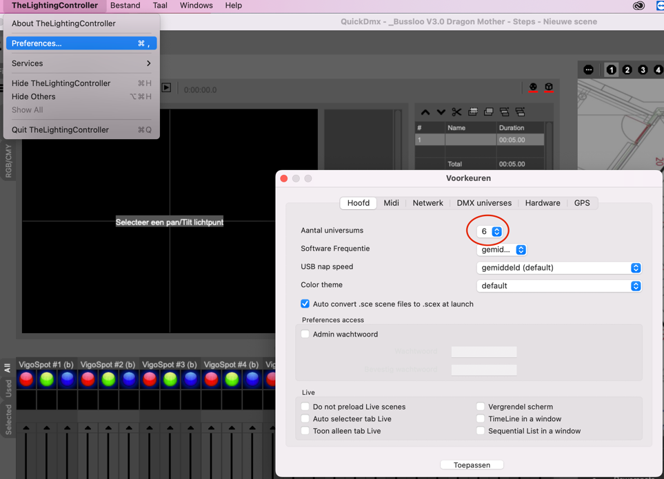

Test Results:
Windows users:
The configuration has been tested and works well under Windows

Mac users:
De configuration has been tested and works well (version 9.2.38 with 3D versie 5.2.0)
Using earlier versions may cause problems in the 3D. The lamps are then not correctly positioned in the 3D Viewer.

Aanleveren Lichtscript:

Wie | Wanneer
Placed participants: | Before september 1
Relegatie round: | Before september 8
Send your light script (including Music and video in your supplied light script) to:

lightscriptwm@gmail.com

What do we offer?
- Light (See configuratie)
- Music
- Video
- Microfoon connection
- 4 DMX switched points 220 volts
- 4 DMX entrances (univers 2)

Lights:
- See configuration)

Music
- MP3 or Wav (Included in the light scrip)

Make sure you also supply the music and movie files together with your light script.

Video
- Picture formaat 1920X1080 FHD (Full HD) is the resolution used by the 1080p and 1080i HDTV video formats.
- MP4 format. Codec: H.264, MPEG-4 Part 10 of AVC (Advanced Video Coding) is een digitale videocodec, die een sterke compressie van videobeelden nastreeft.

Microphone input
- XLR female 3 pin. Mono.
- Entrance on the left on the stage

Effects such as echo, chorus, reverb and other effects are not provided by the organization. If this is desirable, the sauna master must take care of this for themself. Volume is standard for everyone at 0.00 DB

Power Supplies in the Sauna

4 switched points with 220 volts.
- 2 on stage (left and right side)
- 1 under the big table.
- 1 under de small table at the main entrance

DMX

- 4 DMX inputs
- 2 op stage (left and right side)
- 1 under the big table.
- 1 under de small table at the main entrance

